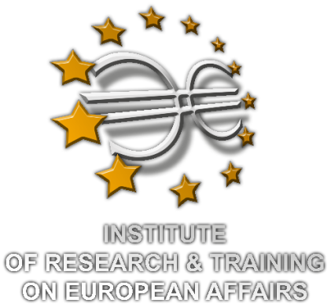

INVITATION
The Institute of Research & Training on European Affairs-I.R.T.E.A. invites you at the Conference, organized in the framework of Development & Democracy Project of the Hellenic Platform for Development NGOs, held on the 11th of December, 2014 at the University of Piraeus premises, Room 101 at 17:00-19:00, with the subject of:
“Introduction on EU Development Effectiveness”
17:00-17:30 Registration
17:30-19:00 Speakers
- C. Kontogoulidou: Head of International Office at University of Piraeus
- F. Vlachos: Development Aid Expert - Policy Officer, "Democracy & Development'" Project
- M. Savrami: Communication Officer "Development & Democracy" Project
The conference will be held in English
Certification of Participation will be provided

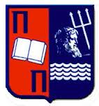
Supported by
Contact us:
Telephone: 213 0250217
email: irtea.greece@gmail.com
International Relations Office

