HELLENIC NAVAL ACADEMY
ATHENS – GREECE
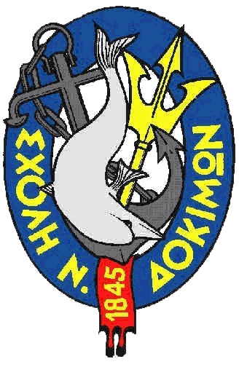

INVITATION
TO MARITIME SECURITY
(MS) MODULE

(European initiative for the exchange of young military officers, inspired by Erasmus)

Dear Colleagues,

The Hellenic Naval Academy under the auspices of the European Security and Defence College, in the framework of the European initiative for the exchange of young military officers, inspired by Erasmus, has the honour to organise a Module, concerning Maritime Security.

The Module is organized according to the curriculum which is under development within ESDC and the Implementation Group. Its aim is to introduce the participants in the contemporary maritime security environment, and to familiarize them with Maritime Security Concepts. The Module will also provide a general knowledge of European Union Maritime Security Strategy, its history and development, its main principles along with the challenges of its implementation.

The module consists of an eLearning part, as well as a residential session, held in the Hellenic Naval Academy, from 24 to 28 April 2017, both parts being compulsory.

We would be pleased if you would accept this invitation and nominate suitable candidates for this training activity.

For further details, regarding the course and administrative information, please refer to the attachments.

Looking forward to welcoming European Cadets, Young Military and Coastguard Officers, during the residential phase of this MS Module.

The Superintendent

Rear Admiral A. Diakopoulos HN

Attachments
- Administrative information
- Application Form

